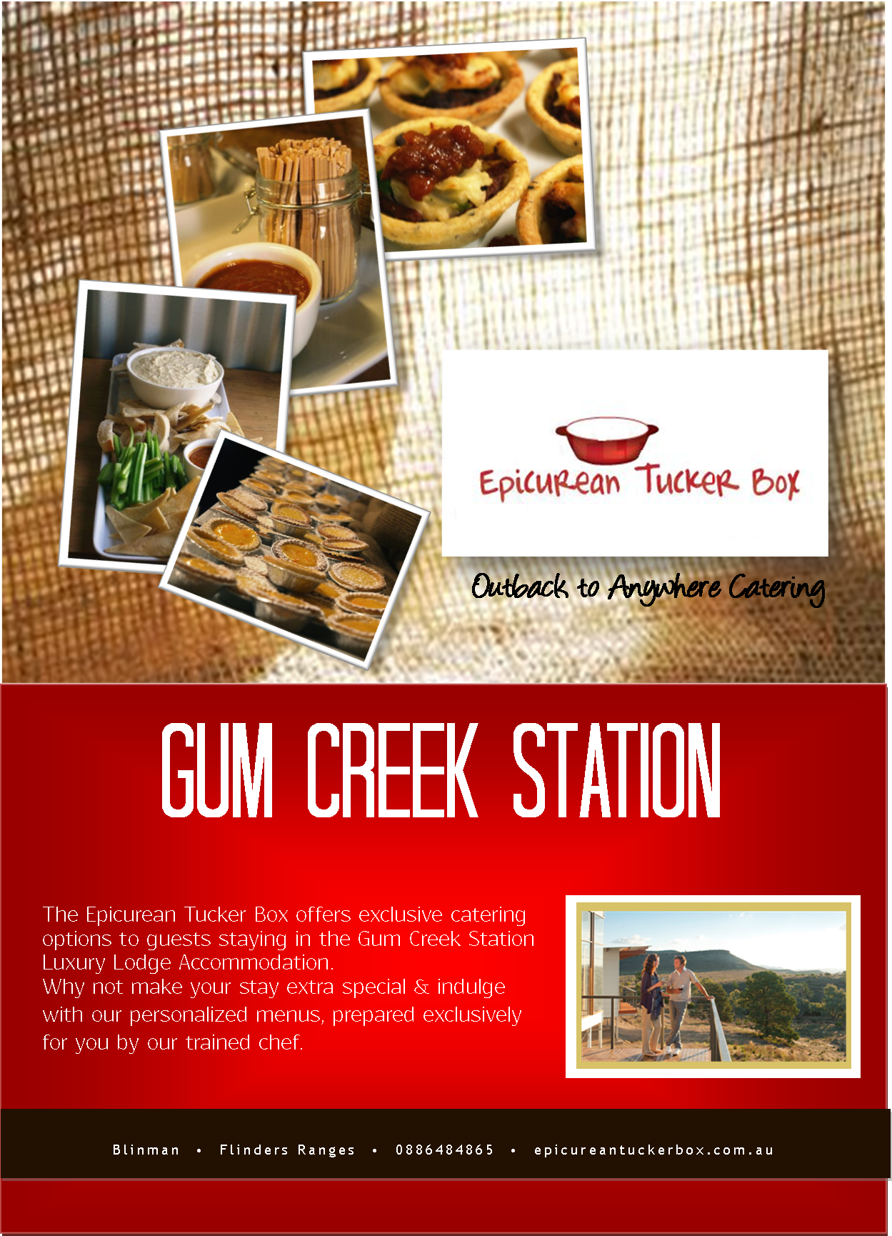

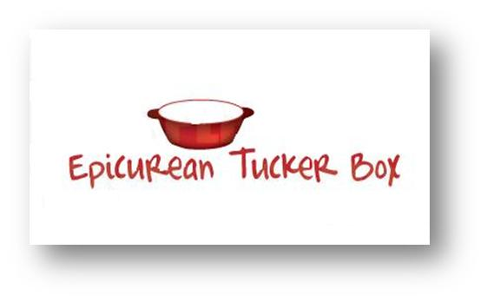

The Epicurean Tucker Box has many options to not only make your stay easier but also more memorable and special.

From a delicious hand crafted breakfast waiting in the cupboard to a fully catered unforgettable meal, your options are limitless!

Here is a preview of what you can expect…..

CONTENTS:

1. **Hand Crafted Breakfast Hampers**
2. **Gourmet Picnic Hampers**
3. **Hand Crafted Platters & Pre Dinner Snacks**
4. **Gourmet Heat & Eat Hampers**
5. **Fully Catered Dinners & Events**



**Hand Crafted Breakfast Hampers**

Before you arrive let us fill the cupboards with all the things you will need to sustain you on your Flinders adventures!

**Continental Breakfast**

* Hand blended toasted muesli with native fruits and spices
* Popular brand cereals
* Home stewed jams & marmalades
* Fresh Breads
* Fresh fruit (home grown when available)
* Milk , juice, tea & coffee

**Cooked Breakfast**

* Free range eggs
* Smoked Mid North bacon & sausage
* Tomatoes & Mushrooms
* Bread & Muffins
* Home brewed sauces & relish
* Milk, juice, tea & coffee



**Gourmet Picnic Hampers**

Whether you’re out walking, riding the trails or out touring the area by vehicle, we can pack you a lunch you won’t soon forget!

Hampers include, but are not limited to:

* Fresh made salads
* Home baked pies
* Cold & cured meats
* Assorted cheeses
* Sandwiches & Rolls
* Fresh fruits
* Home baked cakes & slices
* BBQ Packs

Depending on where you plan to be, your hamper may be packed in a basket, backpack, esky or maybe in one of our souvenir cooler bags. We can even throw in a Barbie plate if you need one!



**Platters & Pre Dinner Snacks**

Enjoy sunset on the deck with a pre prepared platter to share.

**Continental**

A selection of our home made goodies includes; our famous spiced nut mix, homemade dips & breads, marinated olives, roasted vegetables & cured meats.

**Asian**

Selection of Eastern favorites, may include house rolled sushi, steamed dumplings, pickled vegetables, spring rolls, Samosas, yakitori

**Spanish**

Caramalised onion and potato tortilla, olives, pickled vegetables, slow roasted meatballs, shaved meats

**Cheese**

A varied selection of cheeses, soft & hard, stinky and subtle, house made flat breads, crackers & dried fruits & pastes



**Gourmet Heat & Eat Dinner Hampers**

Fully prepared meals can be delivered to the lodge for your convenience.

All meals are fully prepared and only need to be re-heated.

We have a large selection of options and price structures, here is a preview.

**Starters**

Roast Garlic, Potato and Leek Soup with Damper Roll

Smoked Salmon Terrine

Smoked Kangaroo and spring onion Pizzette

SA King Prawn & Cannellini Salad on Sourdough

**Mains**

Lamb Shank Ragout Tartlet

Slow Roasted Chicken with Lemon & Thyme Jus

Slow Roasted Beef Shin with Braised Fennel

Fancy Fish Pie

Char grilled rosemary lamb

Chicken Breast Filled with Smoky Bacon and Camembert

Apricot and pistachio stuffed pork

Beef Ragu Lasagne

House made curry



**Fully Catered Meals & Events**

With an almost unlimited menu to draw on, let us prepare and serve a meal you won’t soon forget! This fully catered option lets you decide on an a la carte menu that will be prepared for you and your guests on site. This service includes a chef and staff where needed. Not limited to the lodge it’s self, this option can be taken on the road! Let us take you to some of the most spectacular destinations on Gum Creek Station to deliver an unforgettable dinner party!

We also specialise in private events, such as weddings, birthdays & anniversaries.

So whether it’s a relaxed dinner for eight at the lodge, an intimate proposal on a hill top or even a happy birthday with friends, we have a menu to suit.

Prices will vary with menu options and staff requirements.

